NEW RELIC OBSERVABILITY
IMPLEMENTATION REPORT
Team 3 · Cencora Order Fulfilment Capstone
2  Telemetry streams | 3  Alert scenarios | 1  Unified dashboard

Prepared for: Global Leadership Review
Prepared by: Siddhesh Chavan, Team 3
Date: 21 October 2026
Scope
New Relic account setup, secure ingestion, Databricks and Airflow telemetry, unified dashboard, alerts, email workflow, loss-of-signal monitoring, and incident recovery evidence.

Executive Summary
Team 3 implemented a unified New Relic observability solution around the existing Cencora Order Fulfilment pipeline. The solution combines Databricks stage telemetry with Airflow orchestration telemetry so leadership can see business-data quality, processing performance, end-to-end pipeline outcomes, and cross-platform run correlation in one place.
Outcome The monitoring layer is operational and validated through three controlled scenarios: Silver rejection percentage above 5%, an Airflow/Silver pipeline failure followed by recovery, and a telemetry loss-of-signal incident followed by heartbeat restoration.

Leadership Highlights
- Secure by design. A dedicated New Relic INGEST-LICENSE key is stored in Databricks and Astro secret mechanisms; credentials are not embedded in notebooks, DAG code, Git, or screenshots.
- Unified visibility. One New Relic dashboard combines Airflow pipeline health with Bronze, Silver, and Gold processing metrics.
- End-to-end correlation. Events carry batch ID, Airflow run ID, task ID, Databricks run ID, status, duration, and other stage-specific metrics.
- Operational alerting. New Relic conditions detect high Silver rejection percentage, Airflow DAG failure, and missing heartbeat telemetry.
- Actionable notifications. A workflow routes matching issues to a verified email destination.
- Recovery proven. The same failed batch was rerun successfully after the controlled cause was removed, with the successful boundary advancing only after Gold completion.

Implemented Scope
Area | Implementation | Validated
New Relic foundation | Fresh account, account ID 8645460, dedicated ingest key, Event API verification | Yes
Databricks telemetry | Bronze ingestion, Silver quality, Gold freshness and output metrics | Yes
Airflow telemetry | Retry, task failure, DAG failure, pipeline completion, heartbeat | Yes
Dashboard | Joint Airflow + Databricks operational view | Yes
Alerts | Rejection >5%, DAG failure, telemetry loss of signal | Yes
Notifications | Policy-filtered email workflow | Yes
Testing | Quality alert, controlled failure/recovery, heartbeat loss/recovery | Yes

1. Solution Architecture
The New Relic layer was added around the working ADLS → Airflow → Databricks pipeline. Spark processing logic remained intact except for telemetry calls after successful stage processing. Airflow callbacks report orchestration outcomes independently of Databricks stage metrics.
ADLS Gen2 | Astro Airflow | Databricks Jobs
landing/batch_NNN | Batch discovery + dependency control | Bronze → Silver → Gold
 | ↓ callbacks | ↓ helper notebook
 | Team3AirflowOrchestration | Team3PipelineRun
 | New Relic Event API | New Relic Event API

Telemetry Streams
Event type | Source | Purpose | Core attributes
Team3PipelineRun | Databricks | Processing, quality, freshness and stage duration | stage, status, batchId, databricksRunId, durationSeconds, inputRows
Team3AirflowOrchestration | Airflow | Retries, failures, completion, heartbeat and run correlation | eventName, status, airflowRunId, taskId, batchId, Databricks run IDs

Security Implementation
- New Relic account ID: 8645460.
- Dedicated ingest key name: team3-order-fulfilment-capstone.
- Databricks secret scope: team3-newrelic; secret key: newrelic-ingest-key.
- Astro environment variables provide NEW_RELIC_LICENSE_KEY and NEW_RELIC_EVENT_URL.
- HTTP calls use bounded timeouts, and delivery failure is logged without replacing the original pipeline outcome.
- Error text is bounded and credential-like content is redacted before being included in telemetry.

2. New Relic Foundation and Secure Ingestion

Account and Event API Validation
A fresh New Relic account was created and a dedicated INGEST-LICENSE key was generated. The first stored secret was incomplete, which produced HTTP 403. After replacing it with the full 40-character value, the Event API returned HTTP 200 with a success response. A Team3PipelineTest event was then retrieved successfully through NRQL.
Checkpoint | Observed result
Account ID | 8645460
Dedicated key | team3-order-fulfilment-capstone
Initial authentication test | HTTP 403 with incomplete 16-character secret
Corrected authentication test | HTTP 200 with full 40-character secret
Connectivity event | Team3PipelineTest visible in New Relic

Reusable Databricks Helper
- Notebook name: sid_team3_newrelic_helper.
- Connection-test notebook: sid_team3_newrelic_connection_test.
- The helper retrieves the ingest key through dbutils.secrets.get.
- The helper builds Team3PipelineRun events and adds the Databricks run ID when available.
- The helper calculates rejectedPercent and applies the zero-input noData rule.
- The helper uses a 20-second HTTP timeout and returns delivery status without failing successful Spark processing.
Zero-input rule If inputRows is zero, rejectedPercent is emitted as 0 and noData is emitted as true. This avoids division-by-zero while preserving the operational distinction between zero rejection and no input.

3. Databricks → New Relic Telemetry

Bronze: Ingestion Metrics
Bronze telemetry reuses the job’s existing result tuples without changing the four-file validation or insert-only Delta MERGE behavior.
Metric | Meaning
inputRows | Total distinct source rows across orders, order_lines, shipment_lines and delivery_events
insertedRows | Rows newly inserted after Delta MERGE
Per-dataset input/insert counts | Orders, order lines, shipment lines and delivery events
durationSeconds | Bronze job runtime
databricksRunId | Databricks job-run correlation value

Replay confirmation: batch_011 reported inputRows = 11 and insertedRows = 0, which demonstrated that existing business keys were not duplicated during replay.

Silver: Data-Quality Metrics
Metric | Source
inputRows | Current-batch rows read from the four Bronze transactional tables
rejectedRows | Rejected orders, rejected order lines, rejected shipment lines, rejected events, duplicates and quarantined events
rejectedPercent | rejectedRows ÷ inputRows × 100
Detailed quality breakdown | Accepted/rejected counts by entity, duplicates and quarantined delivery events
durationSeconds / databricksRunId | Stage runtime and execution correlation

Gold: Publication and Freshness
Metric | Definition
freshnessSeconds | Elapsed time from latest successful Delta commit across the three Gold outputs to telemetry observation
affectedOrders | Orders recomputed for the selected Silver batch
Gold output counts | order_line_fulfilment, order_service_performance and regional_backlog row totals
validationPassed | True only after all blocking Gold checks pass
asOfTime | Airflow-controlled reporting timestamp

A validated Gold test recorded freshnessSeconds = 9 after all three Gold MERGEs and blocking validations completed.

4. Airflow → New Relic Telemetry
The Astro DAG uses reusable callbacks from include/new_relic_telemetry.py. The callbacks are attached without changing batch discovery, parameter passing, Databricks dependency order, successful-boundary logic, or skip behavior.
Airflow event | Trigger | Purpose
task_retry | A task enters retry | Expose retry count, task, exception and remote run correlation
task_failure | Retries are exhausted | Record final task failure without masking the original exception
dag_failure | DAG reaches failed terminal state | Drive the pipeline-failure alert and incident workflow
pipeline_completion | A real batch reaches mark_batch_successful | Record final success and all three Databricks run IDs
heartbeat | Every DAG terminal callback | Prove Airflow → New Relic telemetry is alive, including no-new-batch runs

Correlation Model
- dagId identifies cencora_team_3_order_fulfilment.
- airflowRunId identifies the exact scheduled or manual DAG run.
- batchId/inputBatch identifies batch_NNN when a new batch exists.
- taskId identifies Bronze, Silver, Gold, mark_batch_successful or dag_heartbeat.
- bronzeDatabricksRunId, silverDatabricksRunId and goldDatabricksRunId are included on successful completion.
- errorMessage and exceptionType support failure investigation while sanitized log links support navigation.
No-new-batch behavior A scheduled run with no new batch skips downstream processing but still emits an ALIVE heartbeat. It does not emit pipeline_completion, preventing false claims of business processing success.

5. Unified New Relic Dashboard
The dashboard is intentionally unified. Airflow widgets describe orchestration health, while Databricks widgets describe data processing, quality and freshness.
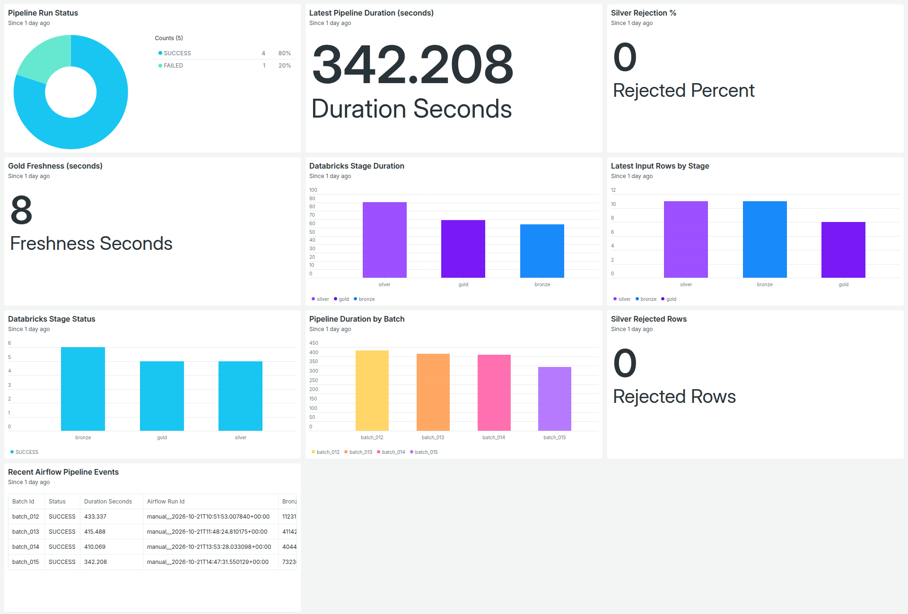
Figure 1. Unified New Relic dashboard combining Airflow and Databricks telemetry.

Widget Ownership
Widget | Telemetry source
Pipeline Run Status | Airflow: Team3AirflowOrchestration
Latest Pipeline Duration | Airflow: Team3AirflowOrchestration
Pipeline Duration by Batch | Airflow: Team3AirflowOrchestration
Recent Airflow Pipeline Events | Airflow with Databricks run-ID correlation
Databricks Stage Duration | Databricks: Team3PipelineRun
Latest Input Rows by Stage | Databricks: Team3PipelineRun
Databricks Stage Status | Databricks: Team3PipelineRun
Silver Rejection % / Rejected Rows | Databricks Silver telemetry
Gold Freshness | Databricks Gold telemetry

6. Alerting and Notification Workflow
Condition | Signal | Threshold / behavior | State
Silver Rejection Percentage > 5% | latest(rejectedPercent) where stage = silver | Critical above 5 using a 5-minute aggregation design | Enabled and validated
Airflow Pipeline Failure | count of dag_failure / FAILED events | Critical above 0 | Enabled and validated
Pipeline Telemetry Loss of Signal | count of heartbeat events | Open issue after 15 minutes without heartbeat | Enabled and validated

Policy and Workflow
- Alert policy: Team 3 - Order Fulfilment Monitoring.
- Issue grouping: one issue per condition.
- Workflow: Team 3 - Order Fulfilment Alerts.
- Workflow filter: the Team 3 monitoring policy.
- Destination: Team 3 Capstone Email.
- Email destination verified; test and real issue notifications received.

Why Heartbeat Was Required
Monitoring pipeline_completion alone would create false loss-of-signal incidents when no new batch exists. A lightweight heartbeat is therefore emitted on every terminal DAG callback. The heartbeat reports status = ALIVE and separately records dagStatus = SUCCESS or FAILED. This distinguishes telemetry health from business-pipeline outcome.

7. Controlled Validation Scenarios

Test 1: Data-Quality Alert Without Pipeline Failure
Item | Observed result
Batch | batch_014
Silver inputRows | 18
Silver rejectedRows | 2
Silver rejectedPercent | 11.111%
Pipeline outcome | SUCCESS through Gold
New Relic | Silver rejection issue opened
Workflow | Email notification received

Purpose: prove that handled invalid records can trigger a data-quality alert while the pipeline continues successfully.

Test 2: Pipeline Failure and Recovery
Phase | Observed result
Failure injection | A temporary Silver RuntimeError was applied only to batch_015
Retry behavior | Airflow emitted task_retry; Silver ultimately failed on try 3
Dependency protection | Gold and mark_batch_successful were upstream-failed
State protection | team3_last_successful_batch remained batch_014
New Relic | task_retry, task_failure and dag_failure were correlated to batch_015
Alerting | Airflow Pipeline Failure issue and email notification received
Recovery | Controlled failure removed; same batch_015 rerun successfully
Final state | Boundary advanced from batch_014 to batch_015
Completion duration | 342.208 seconds

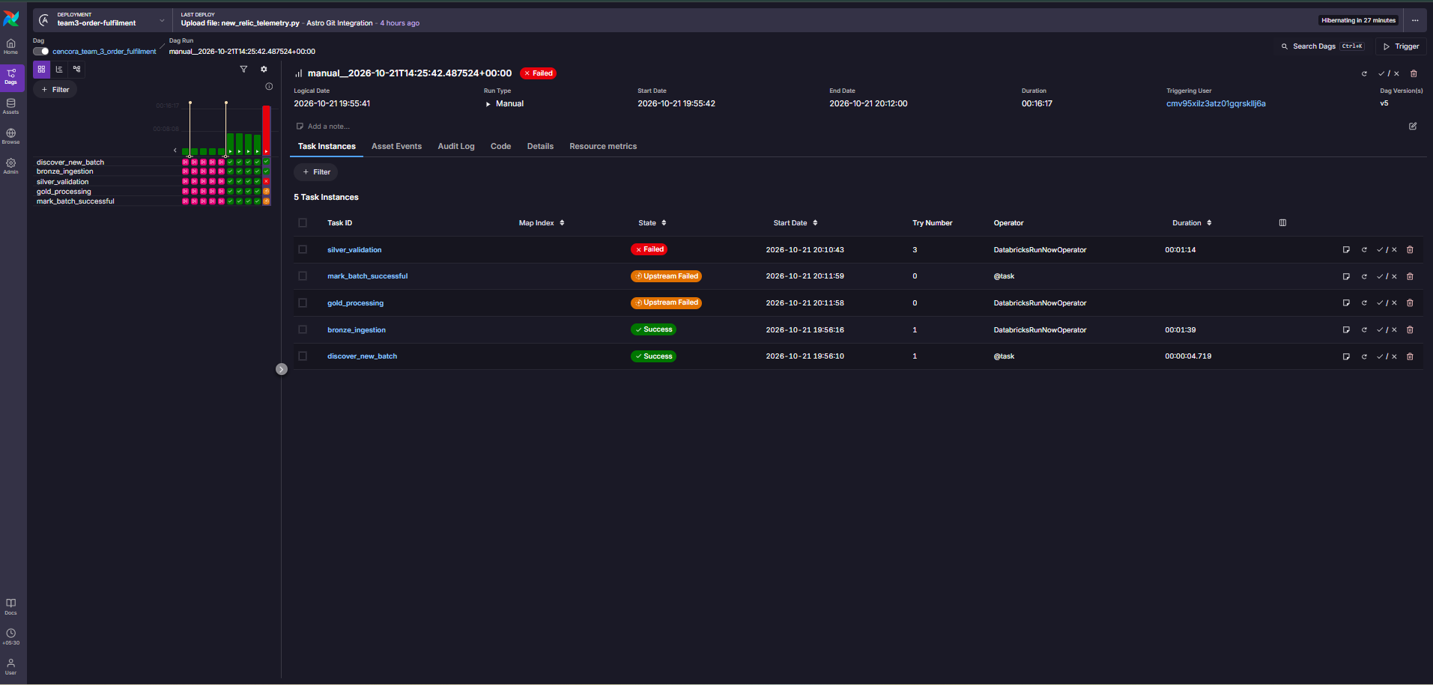
Figure 2. Controlled Airflow failure: Bronze succeeded, Silver failed after retries, and Gold plus the boundary task were blocked.

Test 3: Heartbeat and Loss of Signal
Phase | Observed result
Healthy baseline | Scheduled no-new-batch runs emitted ALIVE heartbeat events
No-op behavior | All processing tasks were skipped while the DAG remained successful
Signal interruption | Schedule temporarily set to None, stopping heartbeats
Alert | Pipeline Telemetry Loss of Signal issue opened
Recovery | Five-minute schedule restored and heartbeat resumed

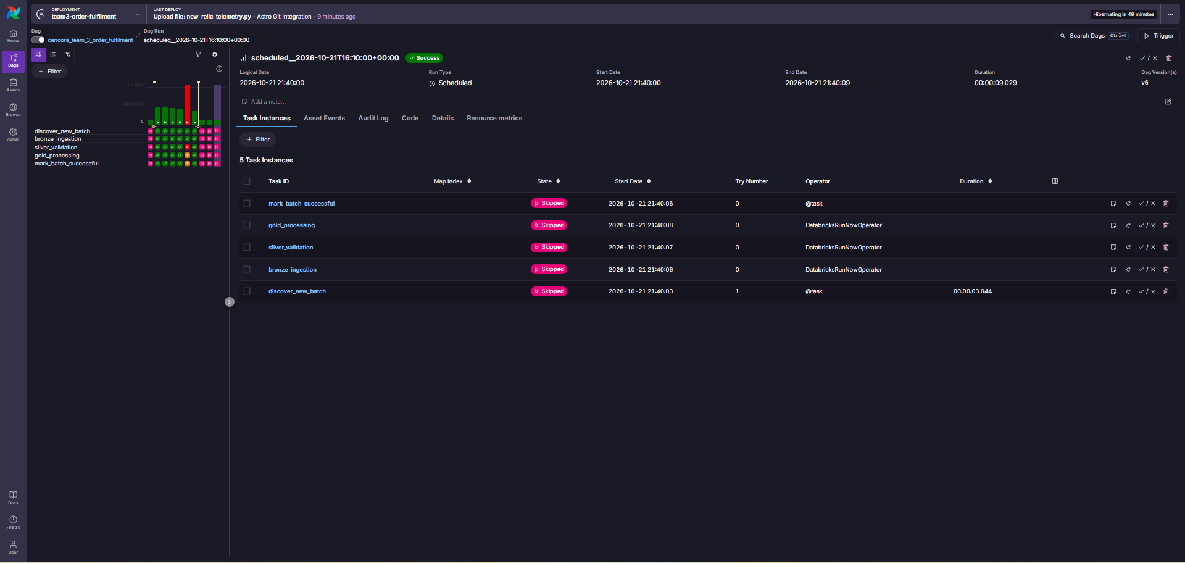
Figure 3. Scheduled no-new-batch run: processing tasks skipped, DAG successful, heartbeat emitted.

8. Operating Model and Recovery Controls

Normal Operation
- Airflow runs every five minutes using schedule="*/5 * * * *".
- No-new-batch runs complete successfully and emit heartbeat only.
- A real new batch executes Bronze → Silver → Gold → mark_batch_successful.
- The successful boundary advances only after Gold succeeds.
- Databricks and Airflow telemetry are sent independently to New Relic.

Failure Handling
- Airflow retries failed tasks according to the DAG policy.
- A failed Silver task blocks Gold and prevents successful-boundary advancement.
- Telemetry delivery errors are logged but do not overwrite the original pipeline outcome.
- A recovery rerun uses the same batch; Bronze’s insert-only MERGE supports replay without duplicate inserts.
- Databricks checkpoints and tables are preserved during troubleshooting.

Key Operational Queries
Pipeline outcomes: FROM Team3AirflowOrchestration SELECT count(*) WHERE eventName IN ('pipeline_completion','dag_failure') FACET status SINCE 1 day ago
Silver quality: FROM Team3PipelineRun SELECT latest(inputRows), latest(rejectedRows), latest(rejectedPercent) WHERE stage='silver' SINCE 1 day ago
Gold freshness: FROM Team3PipelineRun SELECT latest(freshnessSeconds) WHERE stage='gold' SINCE 1 day ago
Heartbeat: FROM Team3AirflowOrchestration SELECT count(*) WHERE eventName='heartbeat' TIMESERIES 5 minutes SINCE 30 minutes ago
Failure/recovery: FROM Team3AirflowOrchestration SELECT count(*) WHERE batchId='batch_015' FACET eventName,status SINCE 1 day ago

9. Leadership Talking Points
- Business value. The solution separates orchestration health from data-quality health, making incidents easier to classify and investigate.
- Traceability. A New Relic issue can be followed from batch ID to Airflow run ID and then to the exact Databricks stage run.
- Controlled state. The successful boundary did not advance during the batch_015 failure and advanced only after the successful recovery.
- Truthful freshness. Gold freshness is based on Delta commit history, not merely job start or end time.
- Failure isolation. Monitoring failures are visible but do not mask the original data-pipeline result.
- Demo confidence. All three alert classes were exercised with real events and real email notification routing.

Suggested 5-Minute Presentation Flow
Time | Content
0:00–0:45 | Objective and architecture: two event streams into one observability layer
0:45–1:45 | Unified dashboard: Airflow outcomes plus Databricks stage, quality and freshness metrics
1:45–2:30 | Test 1: 11.111% Silver rejection alert while pipeline succeeded
2:30–3:45 | Test 2: Silver failure, retries, blocked Gold, protected boundary and same-batch recovery
3:45–4:30 | Test 3: healthy no-op heartbeat, loss of signal and restoration
4:30–5:00 | Security, run-ID traceability and operational conclusion

10. Conclusion
Team 3 completed the New Relic milestone as a production-style observability implementation, not only as a dashboard demonstration. The solution establishes secure ingestion, stage telemetry, orchestration callbacks, cross-system correlation, operational dashboarding, three alert classes, email routing, and controlled recovery evidence. The final implementation now monitors both whether the pipeline is running and whether the data it produces is healthy and fresh.
Final status New Relic observability implementation complete and validated across Databricks processing, Airflow orchestration, dashboarding, alerting, notifications, heartbeat monitoring, incident investigation and recovery.

